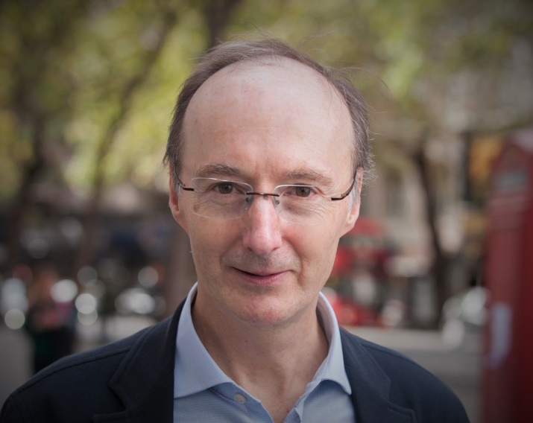

Max Saunders is Interdisciplinary Professor of Modern Literature and Culture at the University of Birmingham. He was Director of the Arts and Humanities Research Institute at King’s College London. He studied at the universities of Cambridge and Harvard, and was a Fellow of Selwyn College, Cambridge. He is the author of _*Ford Madox Ford: A Dual Life_* (2 vols, 1996; paperback 2012); _*Self Impression: Life-Writing, Autobiografiction, and the Forms of Modern Literature_* (2010); and _*Imagined Futures:* *Writing, Science, and Modernity in the To-Day and To-Morrow Book Series, 1923-31_* (2019).